

Gulf Aluminium Rolling Mill Company
ICT Department

e-Bidding System

List of Functionalities

Version No.: 0.1
Revision History
Version | Date | Description of Change | Author
0.1 | 02 Feb. 10 | Initial Document | Noel

Reviewers
Name | Version Approved | Comments | Date

Table of Contents
1. Functionalities 4
1.1. Publish RFQ 4
1.2. List Available Bids 4
1.3. Submit / Update / Withdraw Bid 4
1.4. Create Bid Analysis (Sealed RFQ) 4
1.5. Send RFQ Reminder to Supplier 4
1.6. Supplier Registration 5
1.7. Print PO 5
2. Workflow 6
2.1.1. Publish RFQ 6
2.1.2. Supplier’s Registration 7
3. Assumption 8

Functionalities

Publish RFQ
Buyer will be able to publish RFQ for bidding; suppliers will be selected automatically based on their preferences. An email will be sent to each supplier as a notification.

List Available Bids
Every supplier will be able to view all bids that were published by the Buyer. It will provide them information regarding their position (not rank no. but rather the group they are currently belong to such as lowest bidders or highest bidders). This feature will help them evaluate their quotes against other suppliers; hence providing savings to GARMCO.

Submit / Update / Withdraw Bid
Every participating supplier can submit their quotation; they can even decline from participating in the e-bidding. In addition, they can keep on re-quoting their current bid while the RFQ is not yet closed. An email notification will be sent to Buyer or the Purchasing Manager, depending to the kind of RFQ (Un-sealed or Sealed, respectively), once an RFQ is closed. This is the only time that the quotes of each supplier will be visible to the Buyer/Purchasing Manager.

Create Bid Analysis (Sealed RFQ)
A Bid Analysis will be created during a Tender Committee meeting, in which they will award the RFQ to a supplier based on certain criteria such as price and delivery performance. Supplier information will be provided in a graphical manner to assist the committee in deciding the right bidder.
In other hand, all un-sealed RFQs will be processed from EnterpriseOne.

Send RFQ Reminder to Supplier
Before the closing date of the RFQ, an automatic reminder will be sent to each participating suppliers to give them a chance to re-quote their current bid.

Supplier Registration
Each supplier who wants to participate in the e-Bidding System must register first. During registration a supplier will be asked to select all applicable products or services they can provide. These selections will be used by the system to determine which suppliers should be invited in e-Bidding. In addition, they can set their preferences such as the frequency of email notifications, default list and the likes. The system administrator must approve the registration of the supplier and a confirmation email will be sent to the supplier to activate the account.

Print PO
The winning bidder will be able to print the Purchase Order for the RFQ for reference.

Workflow

Publish RFQ
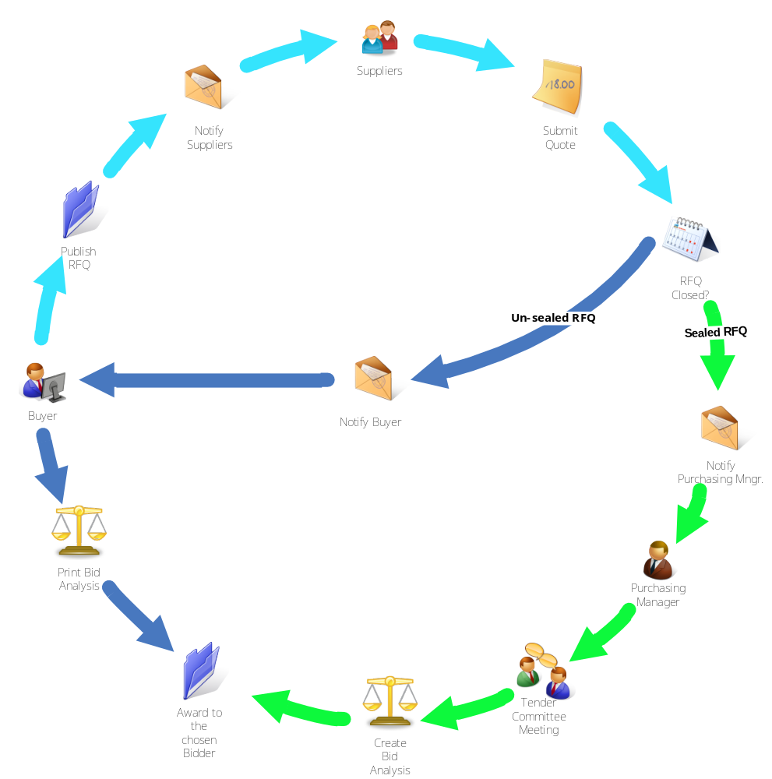
Figure 1: Publish RFQ Cycle

- The Buyer will publish the RFQ that will notify all suppliers based on their respective preferences
- Each Supplier will be able to submit their quotes or even decline from participating in the e-Bidding. In addition, it also possible to re-quote each item as long as the RFQ is not yet closed
- Once the RFQ is closed, it will notify either the Buyer or the Purchasing Manager depending on the total amount
  - The Buyer will be notified once an Un-sealed RFQ is closed
    - From the Enterprise One, the Buyer can print the Bid Analysis and award the RFQ to the chosen supplier
  - The Purchasing Manager will be notified once a Sealed RFQ is closed
    - A Tender Committee meeting will be held and the RFQ will be opened from the system
    - A Bid Analysis will be created and provide a graphical comparison of the different quotes of each Supplier. This will help the committee in choosing the right Supplier. It will also include a graphical history of the Supplier’s Delivery Performance

Supplier’s Registration
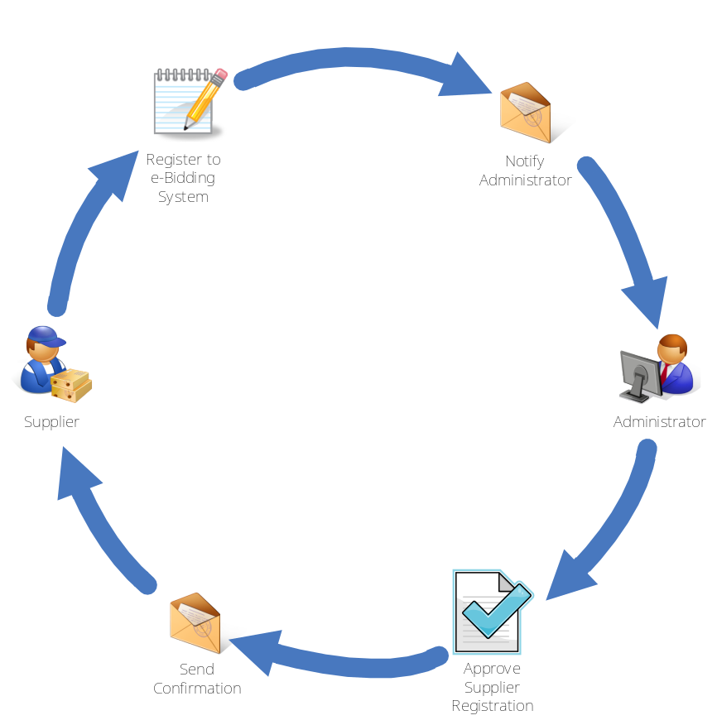
Figure 2: Supplier's Registration Cycle

- Each Supplier must register first before participating in the e-Bidding. A list of Products/Services will be provided in which they have to select the appropriate ones that they provide
- Once completed, the system will notify the Administrator and evaluation the application form of the Supplier
- An email confirmation will be sent to the Supplier once the registration is approved

Assumption
- All Suppliers agree to submit their quotes and accept GARMCO’s Purchase Order (PO) online using the system (What will be the procedure in case Supplier can’t submit their quotes online?)
- Supplier’s history data in terms of delivery time will be generated or provided
- A maximum of 20MB can be uploaded to the system

